

National Textile University

**Department of Computer Science**

Subject:

Operating System

Submitted to:

Sir Nasir

Submitted by:

Asbah Asif

Reg number:

23-NTU-CS-1141

Lab no: 1

Semester: 5th

Task 1:

* Install WSL2

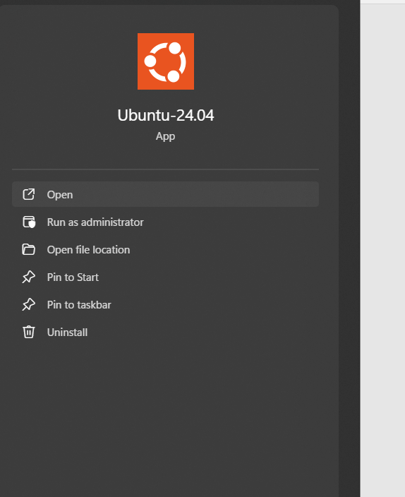

* WSL Installed and Using the command:

**Wsl.exe –install –d Ubuntu-24.04**

* Open Ubuntu and set Username & Password:  
  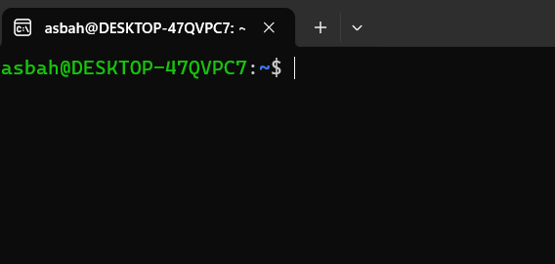
* Upgrade the versions by using Commands:

**Sudo apt update**

**Sudo apt upgrade**

* Install WSL extension on VS Code:



* Configure WSL Ubuntu with VS code:  
  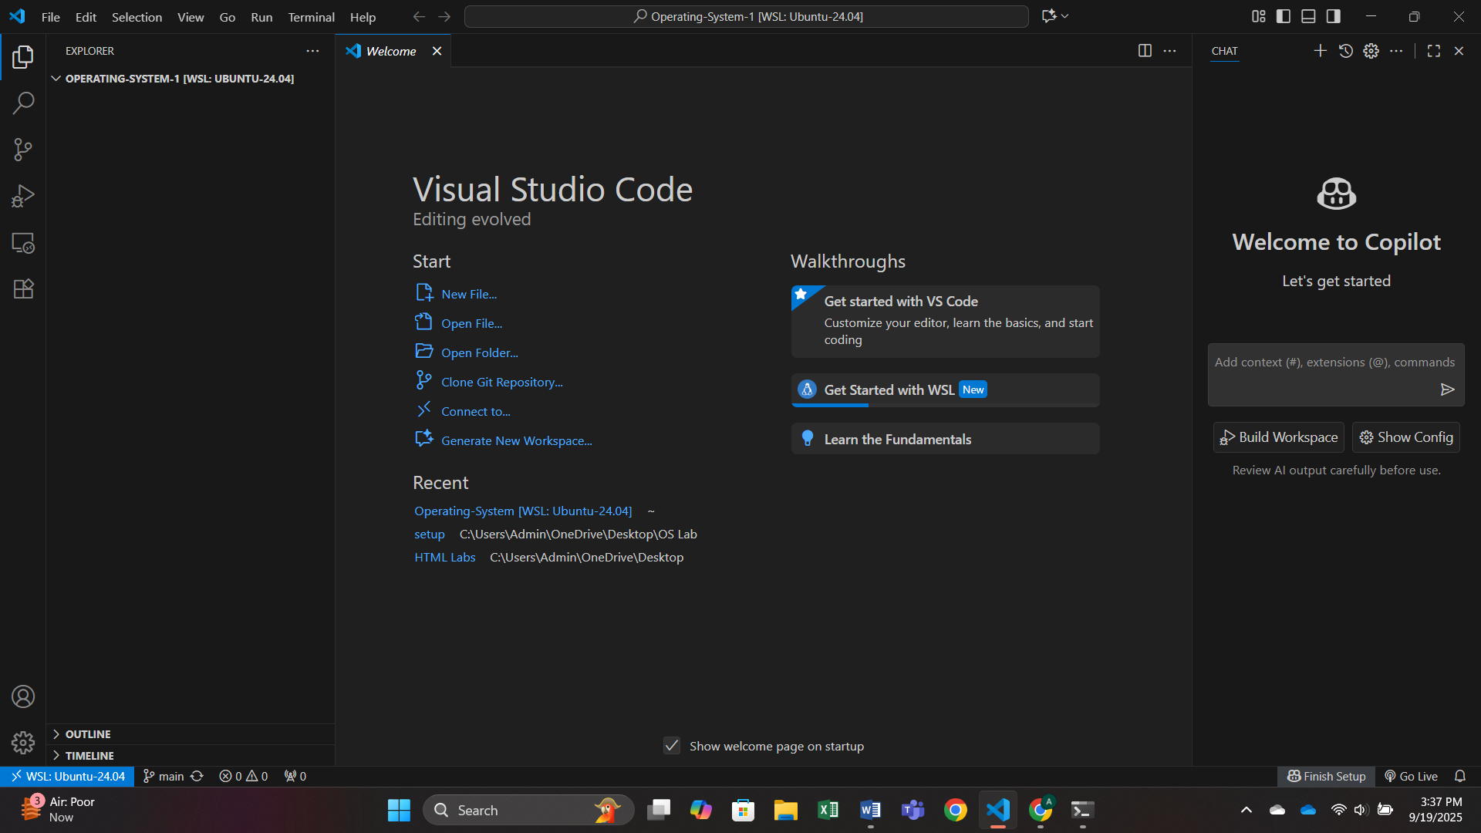
* Create a repository in GITHUB & Clone in VS code:  
    
  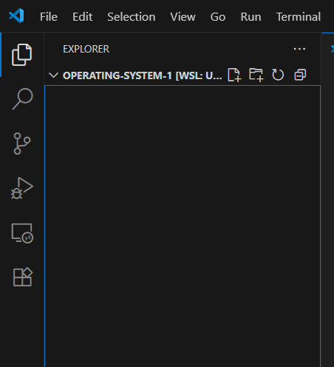
* Check WSL Version:

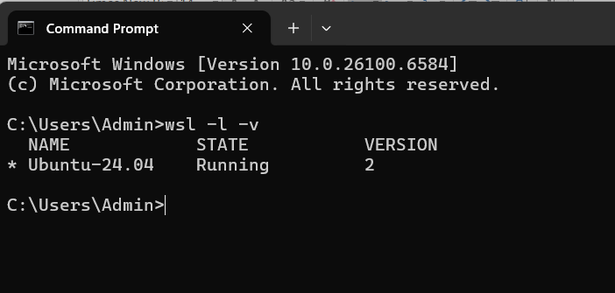

* Check G++ & Gcc Versions:

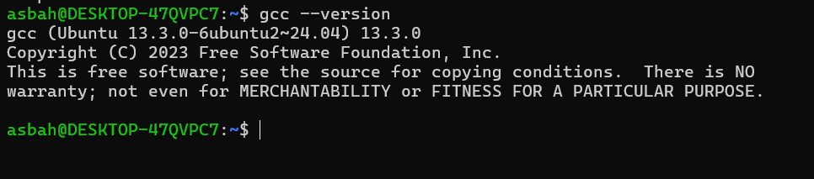

* Configure GIT within Ubuntu:

